Brian Morman Group B EMBA60
Exercise 8
IHW#5: Your firm – Analyze the statement of cash flows
aka – IHW: Your firm’s SCF

Due on ________________
Points possible ________________.

The purpose of this HW is to extend your understanding of (1) the contents and terminology of statements of cash flows and (2) the interpretation of the primary information on the statements of cash flows.

Requirements: Complete the following requirements:

Reading: Chapter 8 from Financial Reporting: First Take.

Analyze your firm’s statement of cash flows for the three years displayed on the statement. You may wish to use the following set of questions to guide your analysis, but you should feel free to use whatever approach you think is most informative.

General
  - How would you characterize the firm and its primary products in terms of a firm’s life cycle (Introductory, Growth, Mature, Decline)? NVIDIA has been incorporated since 1993. It could easily be considered a Mature company with years of financial success. NVIDIA is even the third largest US company by market cap. But given recent years and the drastic changes in technology their product has driven; NVIDIA may better be looked at as a Growth firm.
  - What amount of cash (and short-term securities) does your firm hold as a percentage of total assets and total revenue? Do you think your firm has the “optimal” amount of cash? What are the consequences of the firm having too much cash? Too little cash? - NVIDIA currently has 39% of their total assets in cash and short term investments or 42% of their total annual revenue.

Cash flows from operations
- What is the trend in net income?
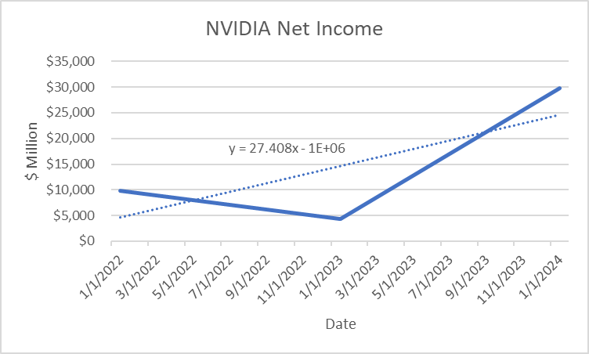
NVIDIA’s net income is trending upward with an average YoY increase of $27.4M The greatest increase comes from FY2024 which posted more than six times the Net income of the previous year.
- How have CFO amounts been changing over the three years? For each of the three years, was CFO greater than or less than net income? What contributed to the difference?
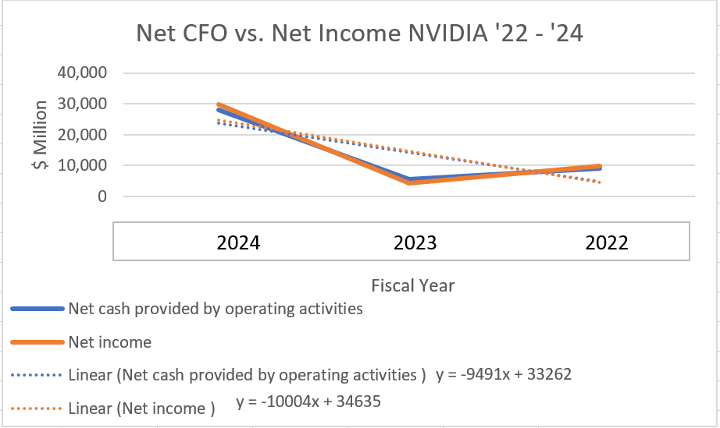
Cash flow from operations does not have a true trend over this three year period but the massive growth in CFO in 2024 shows NVIDIA’s CFO is likely beginning a very positive trend. The R^2 value of this trend line is nearly 50 which shows there is not an accurate fit to the trend but it is interesting to see how closely Net Income matches CFO on this plot. For 2024 and 2022 net income is greater than CFO. In both years this delta can be contributed to a positive difference between cash used in investing and cash provided by financing. With NVIDIA’s financial history its understandable that they would be able to generate a lot of CFF as a very attractive investment for financial organizations
- What is the trend in net income relative to CFO? What reasons might explain this?
Again high R^2 fit for this plot shows there is no linear fit but in general the large increase from ’23 into ’24 comes from the new technology NVIDIA has created that is generating massive operating revenue and increasing interest from lenders.

Cash flows from investing
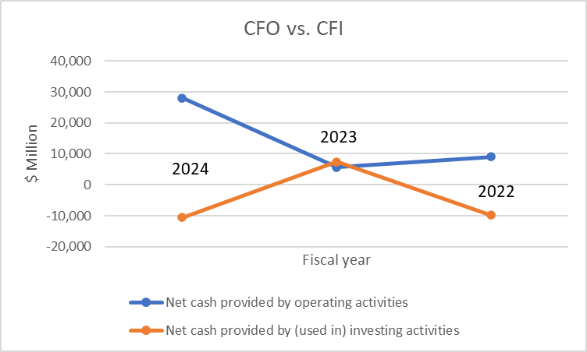
- What has been happening to CFI over the three years? What reasons might explain this? These three years of data show no trend in CFI. Interestingly, NVIDIA generated more cash from investments in 2023 than they used. This delta comes from a very high year in proceeds from marketable securities.
- Do capital expenditures exceed annual depreciation? What are the implications of this?
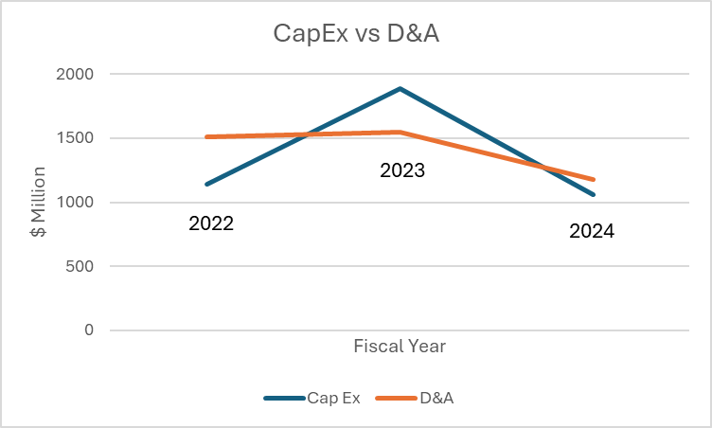
NVIDIA’s CFS mixes CapEx with expenses towards intangible assets and depreciation with amortization which makes it impossible to divorce those two. In 2022 and 2024 capital expenditures were less than D&A. This delta implicates that NVIDIA is a mature company. But in 2023 the ratio is flipped, this shows that NVIDIA is also still growing as result of their technical evolution in recent years.
- Was CFO sufficient to pay for investments? If not, how were investments financed? Yes, in all three years CFO was greater than CFI. In all three years NVIDIA also received income from Financing which would have covered any difference between CFO and CFI if needed.

Cash flows from financing
- What is the trend in CFF?
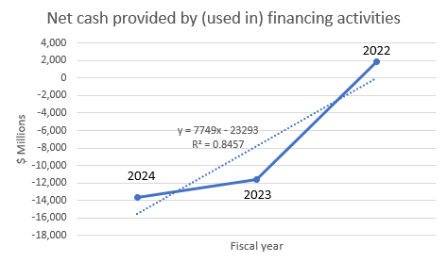
With a fairly low fit, the trend for cash flow from financing is showing a negative trend. This change is overwhelmingly driven by repurchases of common stock during 2023 and 2024.
- What is the trend in dividends?
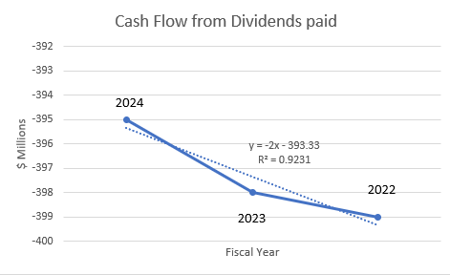
Dividends as seen in the plot above have been basically flat for the last three years from NVIDIA.
- Were dividends paid from internal free cash flows? If external financing was used, can the dividend policy be sustained over time?
Dividends were paid from internal cash flow.
- What type of external financing does the firm rely on—equity, short term debt, long-term debt? Per NVIDIA’s 2024 balance sheet, they hold liabilities of: 1.2B short term debt, 8.5B in long term debt, and 42.9B in shareholder equity. With investor confidence so high it makes sense that NVIDIA is able to rely far more heavily on equity financing.

In general, do you think your firm does an adequate job of discussing its cash flow issues in the annual report? Explain. – NVIDIA’s annual report does an overall good job describing their cash flow. It is a very positive story given NVIDIA’s recent growth. But a potential problem is the blending of PP&E depreciation and amortization from intangible assets. I noticed NVIDIA does have a PP&E cost breakdown in their footnotes that helps demystify this data to an extent but it does not break down the valuation of intangibles and what they are in any real way. In this way, NVIDIA could be creating a cash flow skew on the data that would be hard to unwind. That said the total value of intangibles claimed is 1.12B of NVIDIA’s total 65.7B in assets so that skew is minor if at all. Overall I found that NVIDIA’s annual report tells a pretty complete story for cash flow.

